Robot Chat Test

# Project

The project is divided in 3 folders:

* ChatClient:
  + Contains the code of the tcp client
  + Contains 1 unit test ClientTest.java
* ChatRobot: contains the code of the tcp robot chat
* Binary: contains the binaries from the ChatClient and ChatRobot

# Execute Application

## Using the binaries

1. Execute first ChatRobot.java: “java -jar ChatRobot.java”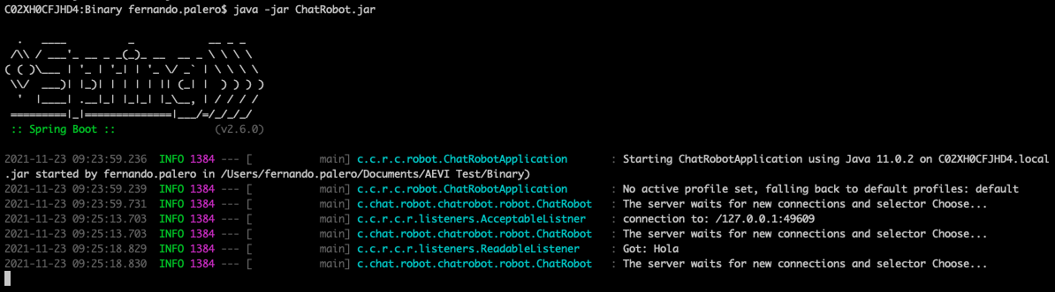
2. Once ChatRobot.java is running execute ChatClient.jar: “java -jar ChatClient.jar”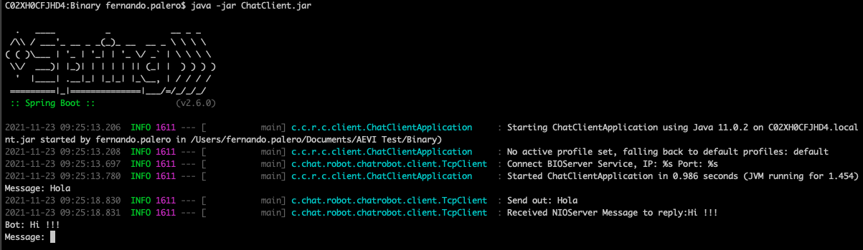
3. After this in the client application write a message and a response will arrive from the bot: “Hi !!”.

## Using Gradle

1. Compile the application ChatRobot and execute:
   1. ./gradlew clean build -> Compile
   2. ./gradlew bootRun -> Execute application
2. Once ChatRobot.java is running then compile the application ChatClient and execute:
   1. ./gradlew clean build -> Compile
   2. ./gradlew bootRun -> Execute application
3. After this in the client application write a message and a response will arrive from the bot: “Hi !!”.

# Execute Test

In the ChatClient code run the gradle command: “./gradlew test”. Only if the test fail in the shell will appear a message.